DAVIS EXPEDITION FUND

REPORT ON EXPEDITION/PROJECT

Expedition/Project Title: The collection of water sediment samples of magnetotactic bacteria

Travel Dates: March – April 2009

Location: Rio de Janeiro, Brazil

Group Members: Denis Trubitsyn

Aims: To collect water sediment samples of magnetotactic bacteria

OUTCOME (not less than 300 words):-

Davis Expedition Fund gave me a great opportunity to accomplish this short field trip to collect water sediment samples of magnetotactic bacteria. Magnetotactic bacteria are a diverse group of prokaryotes with a unique phenotypic feature: the presence of intracellular crystals of magnetite or greigite known as magnetosomes. These organelles are organised in chains that helps to combine their magnetic moment allowing bacterial cells to become oriented the Earth’s magnetic field.

The main principle of isolating these microorganisms from the environment is the so called “race track” method, where a strong magnetic field applied to the end of a capillary helps to concentrate magnetotactic organisms. It has been reported that interesting multicellular magnetotactic microorganisms were isolated in Araruama lagoon in Rio de Janeiro region but it was only possible to analyse them using microscopy at the time.

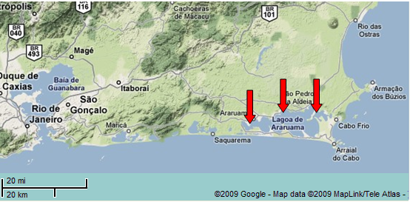
The water samples were collected from 3 different areas in Araruama lagoon (Figure 1). It is known that described magnetotactic bacteria are mostly micro-aerophiles or strict anaerobes. Therefore samples were collected not only from the surface but also from deeper regions ranging from 15 to 100 cm. The highest concentrations of sediment microorganisms were obtained from wet sand sediments as it probably allows the formation of more stable gradients of oxygen concentration.

Figure 1. Araruama Lagoon region. Red arrows show areas where samples have been collected.
The samples collected during this expedition are being processed now. Preliminary results suggest that some multicellular magnetotactic microorganisms can be observed under the microscope in samples that were exposed to a strong permanent magnetic field (Figure 2). Different types of selective media are being used in attempt to enrich cultures with magnetotactic bacteria.
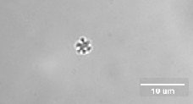

Figure 2. Phase contrast microscopy of sediment sample of magnetotactic bacteria enriched by exposure to the strong magnetic field.

Water samples were plated on marine agar and incubated at 30ºC and at room temperature in order to allow growth of the most of viable microorganisms present in the sample. Examples of such plates can be observed in Figure 3. So far 11 different types of microorganisms have grown and can be isolated from the plates incubated in microaerophilic conditions with 5% oxygen.
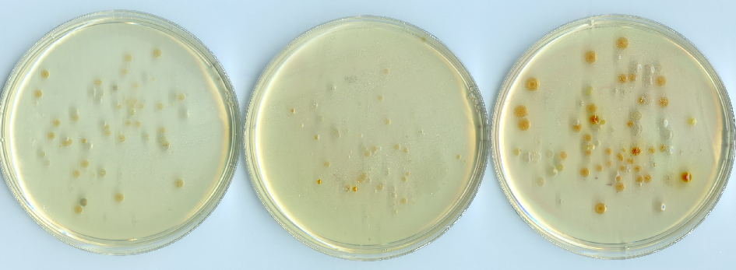
Figure 3. Marine agar plates. Plates were incubated at 30ºC for 48 hours. From the left to the right: air, 2% oxygen and 5% oxygen in nitrogen.

Water sediment samples are going to be used to inoculate “microcosms”, small Winogradsky columns which can be analysed after 16 weeks of incubation for sequences of 16S RNA. This will allow analysis of biodiversity of microorganisms in this area and add to a larger study of Bio-geography.

To summarise, this expedition has been successful and has achieved all its goals. The water sediment samples of magnetotactic bacteria were collected, safely delivered to our laboratory and are being processed. Some preliminary evidence of presence of magnetotactic bacteria in these samples was obtained. Other microorganisms collected during this expedition are already of interest to environmental microbiologists in our department.

